**Information Systems Capstone Project**

**Event Tracking System**

**System Document**

Team Brogrammers

Arpana Pokhrel ([S521571@nwmissouri.edu](mailto:S521571@nwmissouri.edu))

Krishan Kant Sharma ([S534567@nwmissouri.edu](mailto:S534567@nwmissouri.edu))

Venkata Uday Teja Kosireddi ([S534566@nwmissouri.edu](mailto:S534566@nwmissouri.edu))

Kolla Keerthi Chandrika ([S534889@nwmissouri.edu](mailto:S534889@nwmissouri.edu))

Nethala Kavya Daniel ([S534778@nwmissouri.edu](mailto:S534778@nwmissouri.edu))

Manukonda Ravi Chandra ([S534868@nwmissouri.edu](mailto:S534868@nwmissouri.edu))

Table of contents:

1. Introduction
2. Requirement analysis
   1. Software requirements
   2. Hardware requirements
   3. Functional requirements
   4. Non-functional requirements
3. Use case analysis
   1. Use case diagram
   2. Use case scenario
4. Data Flow Diagrams
   1. Context diagram
   2. DFD Level 0 diagram
   3. DFD Level 1 diagram

4.3.1 Create an Event

4.3.2 Update/Edit Event

4.3.3 Track/Edit Attendance

4.3.4 Display Dashboard

4.3.5 Update Holiday List

4.3.6 Manage User account

1. Data Modelling

5.1 ER Diagram

1. User interface design
   1. Login page
   2. Home Page
   3. Admin View
      1. Public and Private Events (Admin)
      2. Edit/Delete an Event (Admin)
      3. View/Track Attendance (Admin)
      4. People Tab (Admin)
   4. Supervisor View
      1. Public and Private Events (Supervisor)
      2. Edit/Delete an Event (Supervisor)
      3. View/Track Attendance (Supervisor)
      4. People Tab (Supervisor)
   5. Student View
      1. View Upcoming Events
   6. Calendar
2. Summary
3. **Introduction**

The Event Tracking System’s objective is to provide a system required by Northwest Missouri State University to track attendance of the students who attend the private and public events conducted by different departments and to help the faculty capture and store the data in nested data format structure.

1. **Requirement Analysis**
   1. **Software Requirements**

* Operating System: Windows 7 and above, Mac OS, Android OS
* Database: MS Excel
  1. **Hardware requirements**
* Laptop and Desktop
* Kiosks
* Swiper

* 1. **Functional requirements**
     1. **Admin**:

1. The admin should be able to create, edit or delete all types of events
2. The admin should be able to add supervisor and give access to another admin while the admin is not available.
3. The Admin should be able to add and give permission to multiple supervisors at the same time to create an event.
4. The Admin should be able to view the dashboard in different view like supervisor’s view or user’s view.
5. The Admin should be able to view the dashboard with all the event information and details
6. The Admin should be able to edit and load all the information about the events.
7. The Admin should be able to post information about the events.
8. The Admin should be able to track the activities of the students.
9. The Admin should be able to add the attendee while creating a private event with a separate form with their information like student ID, first name, last name, email ID, department, role, and allocated hours
10. The Admin should be able to view time-in and time-out of all the students for every event.
11. The Admin should have the ability to download the clock-in and clock-out time reports of attendees for each event in excel files
12. The Admin can update holiday lists and restrict events to be created on that day.
13. The Admin should be able to download the excel files which contain the metadata of the events.
14. The Admin should be able to add or delete hours for users if necessary
15. The Admin should be able to make changes or deny hours, if extra hours has been logged in by the users.
    * 1. **Supervisor**:
16. The Supervisor should be able to create public and private events
17. The Supervisor should be able to add other supervisors for the events they created
18. The Supervisor should be able to view the dashboard in like supervisor’s view
19. The Supervisor should be able to view the dashboard with all the information and details of the events they have created.
20. The Supervisor should be able to edit and load all the information about the events they have created
21. The Supervisor should be able to post information about the events they created
22. The Admin should be able to track the activities of the students who attended the event they created
23. The Supervisor should be able to add the attendee while creating a private event with a separate form with their information like student ID, first name, last name, email ID, department, role, and allocated hours
24. The Supervisor should have the ability to download the clock-in and clock-out time reports of attendees for each event in excel files
25. The Supervisors should be able to view the current and past events that they created
26. The Supervisors should be able to post information or description about the events.
27. The Supervisors should be able to add or delete hours for users if necessary
28. The Supervisors should be able to make changes or deny hours, if extra hours have been logged in by the users.

* + 1. **User**:

1. The User should be able to login with their northwest Student Id and password.
2. The User should be able to view all the upcoming public events and private events that they are part of.
3. The User should be able to view all the attended events.
4. The User should be able to search for upcoming events.
5. The Users should not be able to edit or manage any events.
6. The Users should be able to download the report for the events they have attended so that they can review their time to enter in the timesheet.
   * 1. **System**:
7. The system should allow only the northwest students/staff to login.
8. The System should allow the user the use the same ID and password used for Canvas
9. The System should be able to successful authenticate the user and display the homepage.
10. The System should be able have three different views which are Admin, supervisor and User.
11. The System should allow the user to login and logout of their account anytime.
12. The System should be able to verify and check if the two events collide through the event time and location, if so than the system should deny one.
13. The System should display a message in a dialog box reminding about their remaining hours when they record their time in.
14. The System should be able to send the invitation to all the users who are invited to a private event.
15. The System should be able to verify if the room is occupied or not occupied and make the decision to accept if it’s not occupied and deny if it’s occupied.
    * 1. **Report and Analysis**:
16. Event summary reports may count the events within a date range in their appropriate classifications. This information can be used for actual and/or projected statistics.
17. Students summary reports may show the number of events and number of hours within a given date range, for all or selected events.
18. Location Summary report may show the number of events for a location within a given date range.
19. Occupancy report may show the usage of a location within a given date range.
20. Space utilization reports may show the total bookings for selected locations by each month specified.
21. Lost reports may show the analysis of why events once booked were cancelled.
22. Economic impact reports show the hours amount generated for the students for all events within a given date range.
    1. **Nonfunctional Requirement**
       1. **Operational**:
23. The system operates on any device that has a browser i.e. computers and handhelds.
24. The system must be compatible with all major web browsers (Internet Explorer, Google Chrome, Mozilla Firefox, and Safari).
    * 1. **Performance**:
25. The system shall operate on any device that has a browser i.e. computers and handhelds.
26. The system must be compatible with all major web browsers (Internet Explorer, Google Chrome, Mozilla Firefox, and Safari).
27. The system should generate all reports promptly at any time.
28. The system must not accept more than one booking for a room.

2.4.3 **Security**:

1. The system will provide a process to support identification and authentication.
2. Each unsuccessful attempt by a user to access an item of data shall be recorded on an audit trail.
3. Users shall receive notification of profile changes via preferred communication method of record when profile information is modified.
4. Proper Network Protocols should be used, TCP ports should be used for HTTP and HTTPS
5. Only Supervisors and Admin will be allowed to change, create or edit the events.
6. Users/ Students will not be able to see the information about the other attendees in public events & private events.

2.4.4. **Cultural/Political**:

1. As the system will be built on English language to communicate with the user.
2. Personal information is protected in compliance with data protection act.
3. The system should not use any icon or terms that could be considered offensive in any ways.
4. **Use Case Analysis**
   1. **Use Case Diagram**

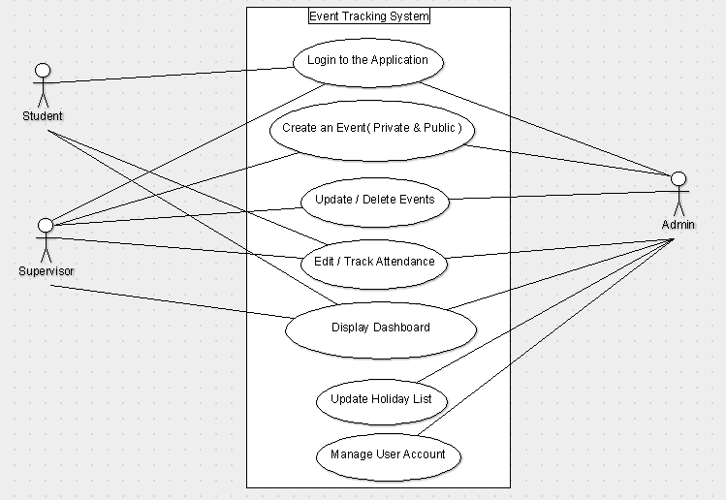

* 1. **Use case Scenarios**

|  |  |  |  |  |  |  |
| --- | --- | --- | --- | --- | --- | --- |
| Use Case Name: Log in | | | ID: 01 | | Priority: High | |
| Brief Description: All Student, Admin and Supervisors can log in into the System with their Northwest Id’s and Password. | | | | | | |
| Actor: Student, Admin, Supervisors | | | | | | |
| Trigger:  Type External ◻ Temporal | | | | | | |
| Preconditions:   1. Student, admin and supervisors should have valid Northwest Id and Password. | | | | | | |
| Normal Course:   1. The user input the username and password. 2. System authenticate the credentials with the database. 3. The credentials are verified from the database to complete log in.    1. If system verifies the user log in to the system log in is successful    2. If the system does not verify, the notification is sent to the user for invalid | | | | Information for Steps  Log in information  Credentials  Invalid notification | | |
| Summary:  Inputs Source Outputs Destination | | | | | | |
| Log in Information  Credentials | User  User File | Invalid notification | | | | User |

|  |  |  |  |  |  |  |
| --- | --- | --- | --- | --- | --- | --- |
| Use Case Name: Create an Event | | | ID: 02 | | Priority: High | |
| Brief Description: Admin and Supervisors can have access to create public and private events. | | | | | | |
| Actor: Admin, Supervisors | | | | | | |
| Trigger:  Type External ◻ Temporal | | | | | | |
| Preconditions:   1. The user must be signed in as Admin or Supervisor 2. Admin and Supervisor must have detail information about the event 3. Admin and supervisor can have list of students to be added for the private events 4. Admin and Supervisor have booked the room for the event | | | | | | |
| Normal Course:   1. User select the type of the event to the system. 2. User enters detailed information of the event such as date, time, location 3. User adds the list of attendees into the system for private events 4. The system will save the event to the database 5. The system sends the invitation to all the attendees for private event | | | | Information for Steps  Event type  Event details  Attendees list    Event details  Invitation Emails | | |
| Summary:  Inputs Source Outputs Destination | | | | | | |
| Event type  Event details  Attendees List | User  User  User | Event details  Invitation Emails | | | | Event Data File  User |

|  |  |  |  |  |  |  |
| --- | --- | --- | --- | --- | --- | --- |
| Use Case Name: Update/Delete Event | | | ID: 03 | | Priority: High | |
| Brief Description: Admin and Supervisors can have access to update/delete public and private events they created. | | | | | | |
| Actor: Admin, Supervisors | | | | | | |
| Trigger:  Type External ◻ Temporal | | | | | | |
| Preconditions:   1. The user must be signed in as Admin or Supervisor 2. Supervisor must be the one who created the event | | | | | | |
| Normal Course:   1. The system will list all the upcoming event details 2. User selects the event to be updated    1. The user enters the updated information of the event    2. The updated information will be displayed 3. User selects the event to be deleted    1. The user deletes the event 4. The system will save the updated details of the event to the database 5. The system sends the invitation to all the attendees for private event with the updated information. | | | | Information for Steps  Event list  Event ID  Event details  Updated event details  Event detail    Updated Event details    Invitation Emails | | |
| Summary:  Inputs Source Outputs Destination | | | | | | |
| Event ID  Event detail | User  User | Event list  Updated event details  Invitation Emails | | | | User  Event Data File  User |

|  |  |  |  |  |  |  |
| --- | --- | --- | --- | --- | --- | --- |
| Use Case Name: Edit/Track attendance | | | ID: 04 | | Priority: High | |
| Brief Description: All Student, Admin and Supervisors can edit/track the attendance for the events | | | | | | |
| Actor: Student, Admin, Supervisors | | | | | | |
| Trigger:  Type External ◻ Temporal | | | | | | |
| Preconditions:   1. Student, admin and supervisors should have logged in to the system. 2. Supervisor must be the one who created the event 3. Student must have attended the event | | | | | | |
| Normal Course:   1. The system will list all the events 2. The user will select the event for the list 3. The system will display the attendance detail 4. Users can edit/track their attendance    1. The students will be able to view and download their attendance report for the events they attend    2. The supervisors will be able to track, edit and download the attendance report for the events they created    3. The admin will be able to track, edit and download the attendance report for all the events 5. The system will save the edited attendance | | | | Information for Steps  Event List  Event Id  Attendance detail  Attendance detail  Attendance report  Attendance update  Attendance report  Attendance update  Attendance reports  Attendance update | | |
| Summary:  Inputs Source Outputs Destination | | | | | | |
| Event list  Event id  Attendance detail  Attendance update | Event attendance file  User  Event attendance file  User | Attendance detail  Attendance update  Attendance report | | | | User  Event attendance file  User |

|  |  |  |  |  |  |  |
| --- | --- | --- | --- | --- | --- | --- |
| Use Case Name: Display dashboard | | | ID: 05 | Priority: High | | |
| Brief Description: After user login, different user can view different dashboard. | | | | | | |
| Actor: Student, Admin, Supervisors | | | | | | |
| Trigger:  Type External 🞎 Temporal | | | | | | |
| Preconditions:   1. Student, admin and supervisors should have logged in to the system. | | | | | | |
| Normal Course:   1. The system identifies the user 2. The system will display the dashboard    1. If the user is student, the system will display the student view dashboard.       1. The system will list all the private events they are invited to.       2. The system will list all the public events.       3. The system will list the number of upcoming events.       4. The system will list all the number of private and public events previously attended    2. If the user is supervisor, the system will display the supervisor view dashboard.       1. The system will list all the private events they are created.       2. The system will list all the public events they created.       3. The system will list the number of upcoming events.       4. The system will list all the number of private and public events previously created by the user.    3. If the user is an admin, the system will display the admin view dashboard.       1. The system will list all the private events.       2. The system will list all the public events.       3. The system will list the number of upcoming events.       4. The system will list all the number of private and public events previously created. | | | | | | Information for Steps  User ID  Event list  Upcoming event stat  Event attendance stat  Event list  Upcoming event stat  Event attendance stat  Event list  Upcoming event stat  Event attendance stat |
| Summary:  Inputs Source Outputs Destination | | | | | | |
| User ID | User | Event List  Event attendance stat  Upcoming event stat | | | User  User  User | |

|  |  |  |  |  |  |  |
| --- | --- | --- | --- | --- | --- | --- |
| Use Case Name: Update holiday list | | | ID: 06 | | Priority: High | |
| Brief Description: Admin can update the holiday list in calendar to restrict event creation. | | | | | | |
| Actor: Admin | | | | | | |
| Trigger:  Type External 🞎 Temporal | | | | | | |
| Preconditions:   1. Admin should have logged in to the system. | | | | | | |
| Normal Course:   1. The system will display the calendar 2. Admin selects the date in the calendar to be updated 3. Admin enters the holiday 4. The system will update the calendar 5. The system will not allow any events to be created on Holidays. | | | | Information for Steps  Calendar  Calendar detail  Holiday list  Calendar detail | | |
| Summary:  Inputs Source Outputs Destination | | | | | | |
| Calendar detail  Holiday List | Admin  Admin | Calendar  Calendar detail | | | | Admin  Calendar file |

|  |  |  |  |  |  |  |
| --- | --- | --- | --- | --- | --- | --- |
| Use Case Name: Manage user account | | | ID: 07 | | Priority: High | |
| Brief Description: Only Admin can manage user account by providing authority as supervisor. | | | | | | |
| Actor: Admin | | | | | | |
| Trigger:  Type External 🞎 Temporal | | | | | | |
| Preconditions:   1. Admin should have logged in to the system. | | | | | | |
| Normal Course:   1. The system will list all the users 2. The Admin can search for the user 3. The Admin can assign the role as supervisor to the user 4. The Admin can remove the user from supervisor role 5. The Admin updates the new role for the user and gives access to the user as Supervisor. 6. The system saves all changes and updates | | | | Information for Steps  User detail  User ID  Supervisor detail  Role remover  Authorities info  Updated user info | | |
| Summary:  Inputs Source Outputs Destination | | | | | | |
| User detail  User ID  Supervisor detail  Role remover | User Data File  Admin  Admin  Admin | Authorities info  Updated user info | | | | User  User file |

1. **Data Flow Diagrams**
   1. **Context diagram**

* 1. **DFD Level 0**

* 1. **DFD Level 1**
     1. Create an event

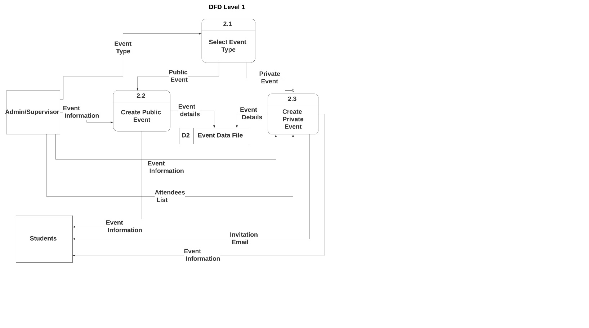

* + 1. Update/Delete Events

* + 1. Edit/Track Attendance

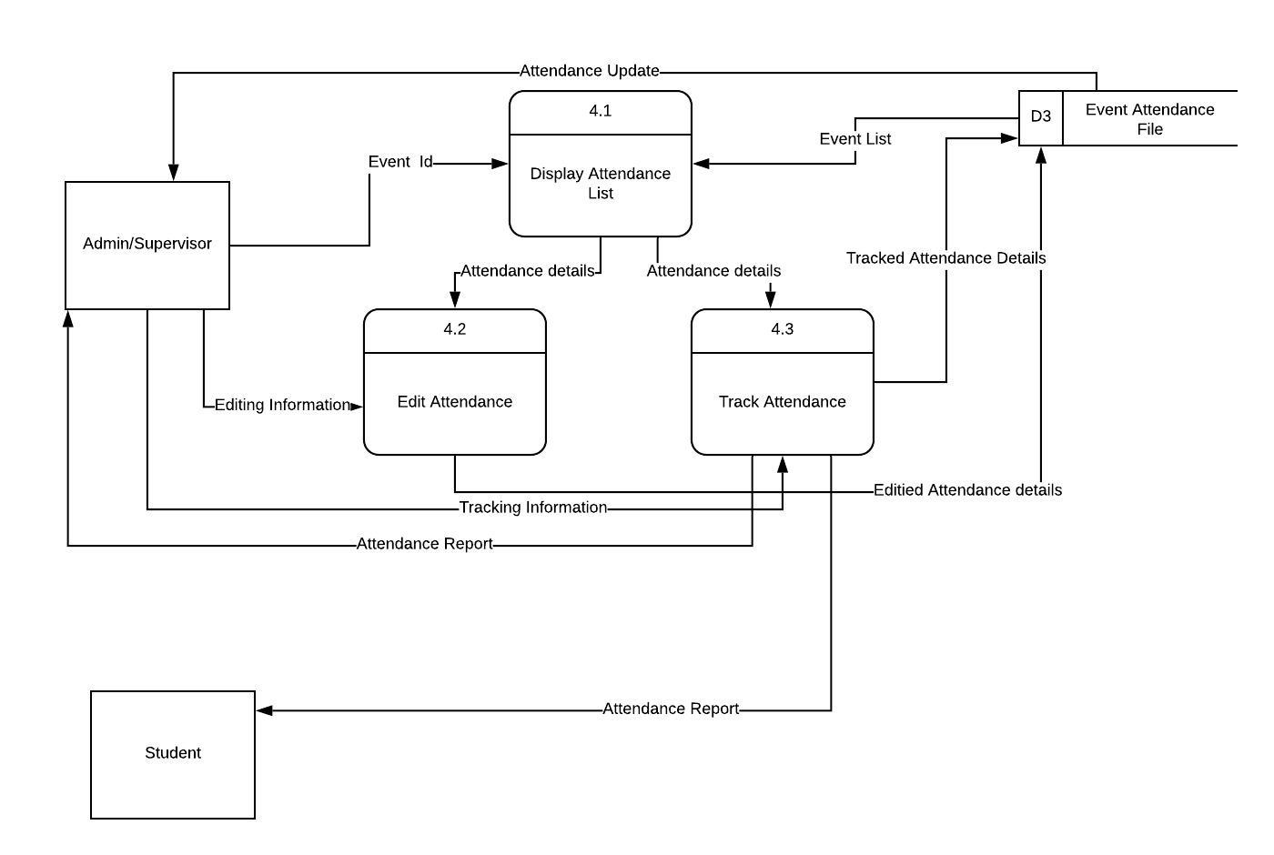

* + 1. Display Dashboard

* + 1. Update Holiday List

* + 1. Manage User Account

1. **Data Modeling**
   1. **ER Diagram**

1. **User Interface Design**
   1. **LOGIN PAGE**

* 1. **HOME PAGE**

* 1. **ADMIN VIEW**

* + 1. Public and Private Events (Admin)

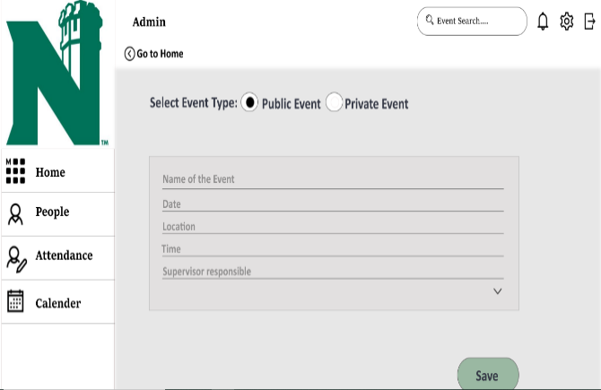

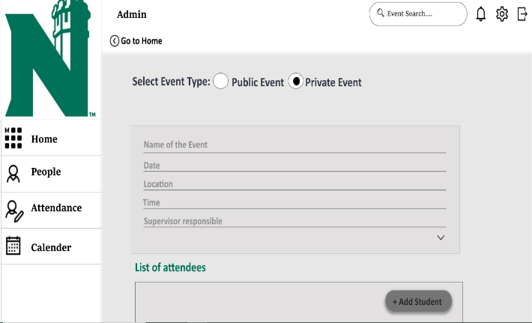

* + 1. Edit/Delete an Event (Admin)

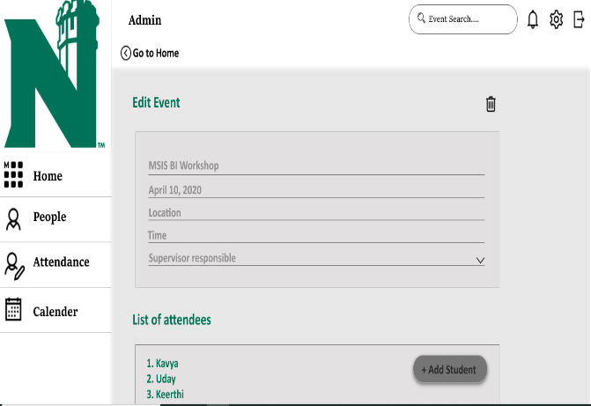

* + 1. View/Track Attendance (Admin)

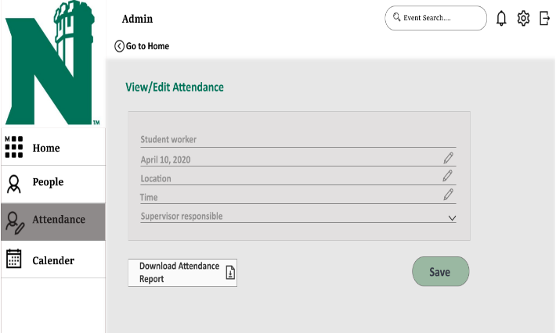

* + 1. People Tab (Admin)

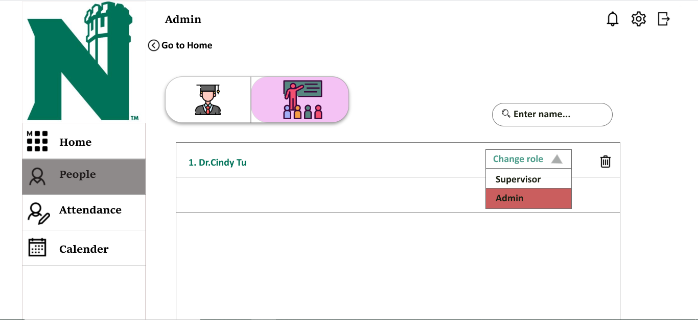

* 1. **SUPERVISOR VIEW**

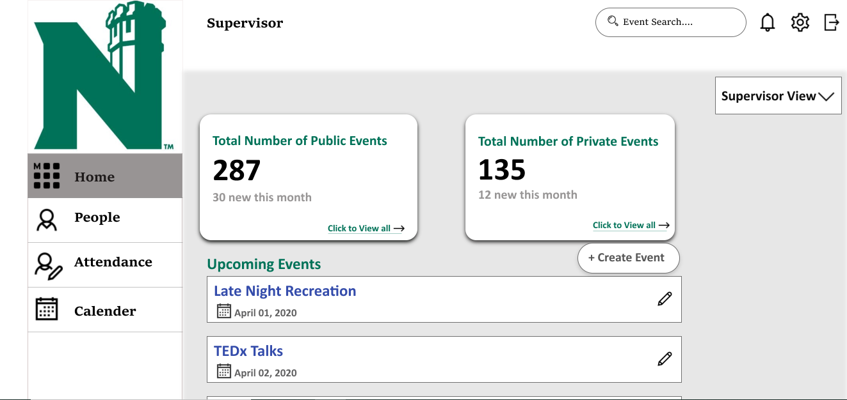

* + 1. Public and Private Events (Supervisor)

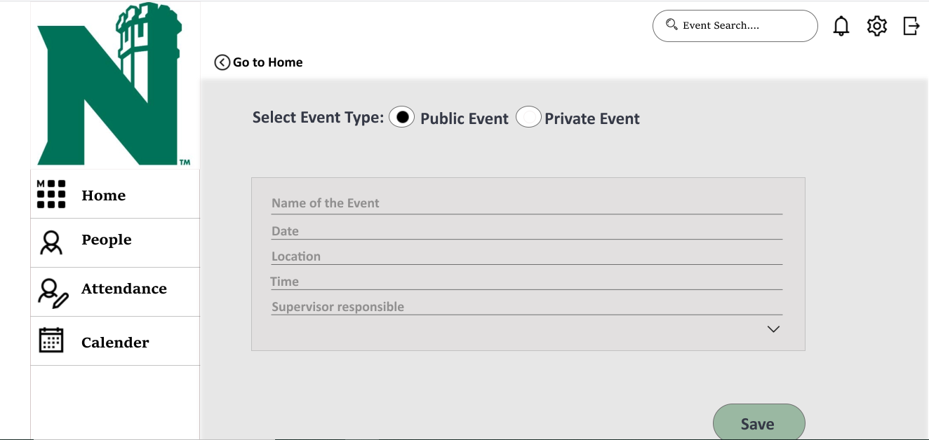

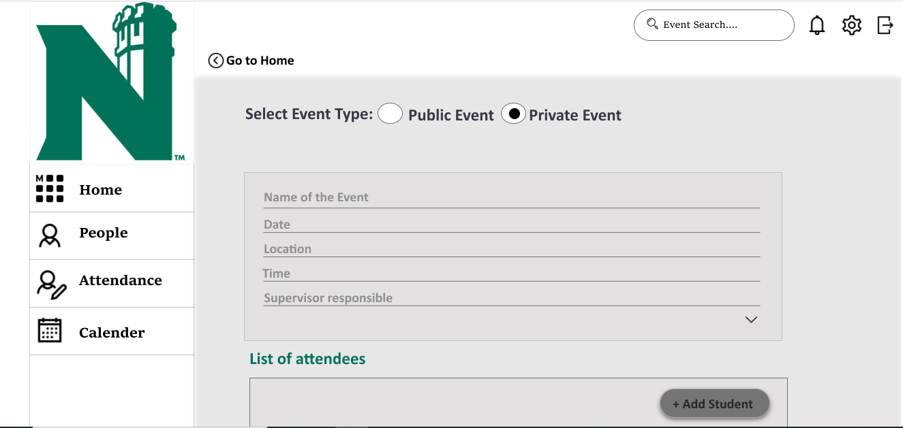

* + 1. Edit/Delete an Event (Supervisor)

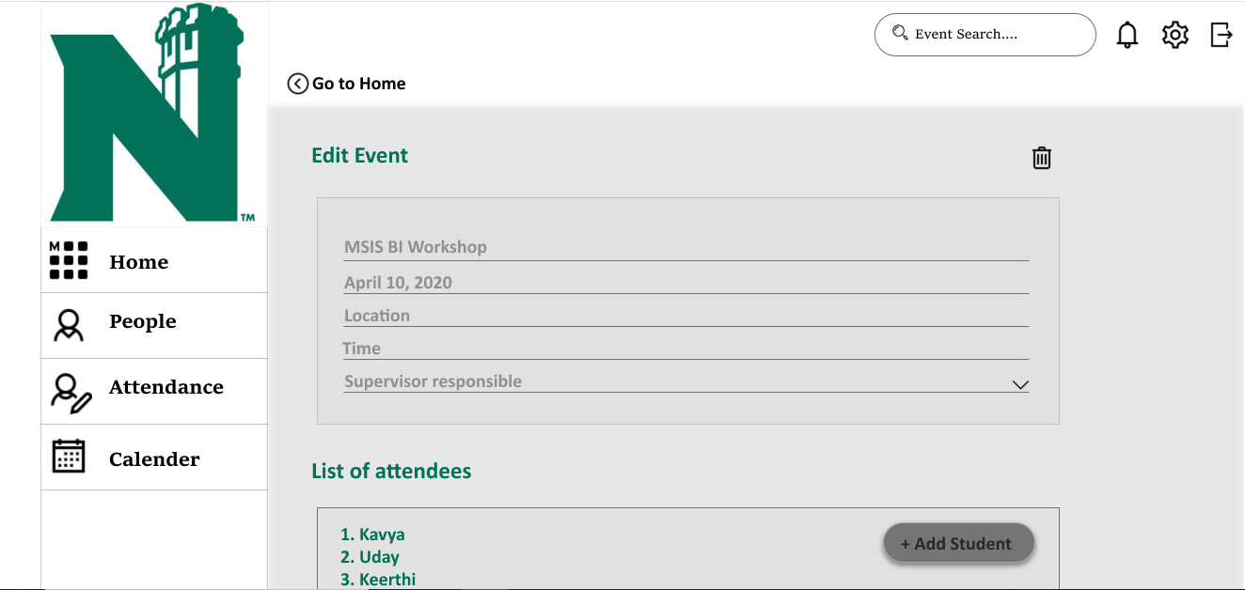

* + 1. View/Track Attendace (Supervisor)

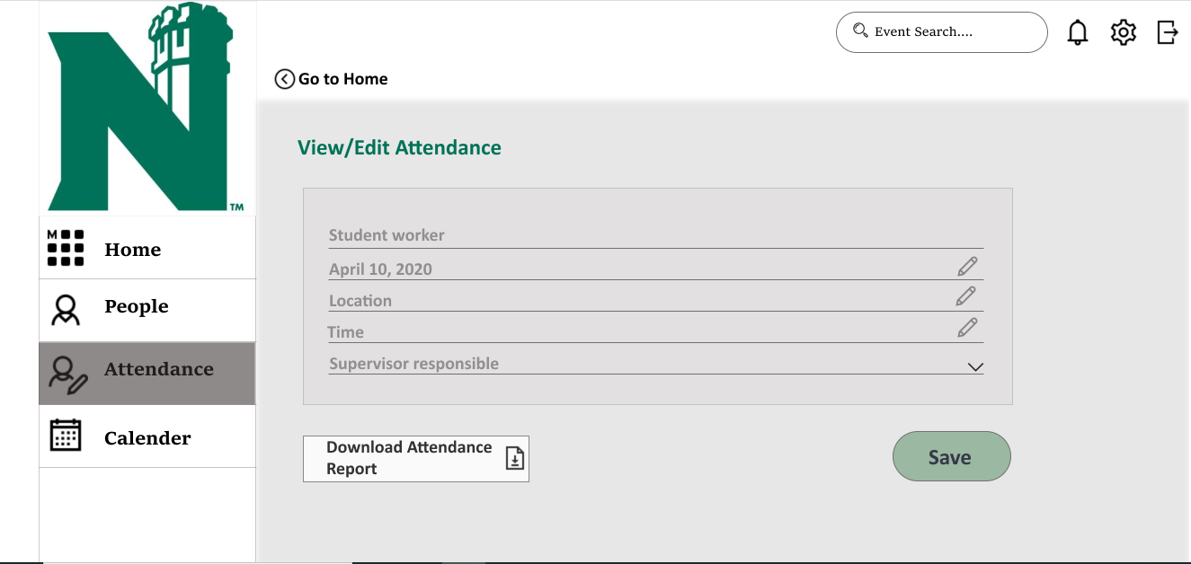

* + 1. People Tab (Supervisor)

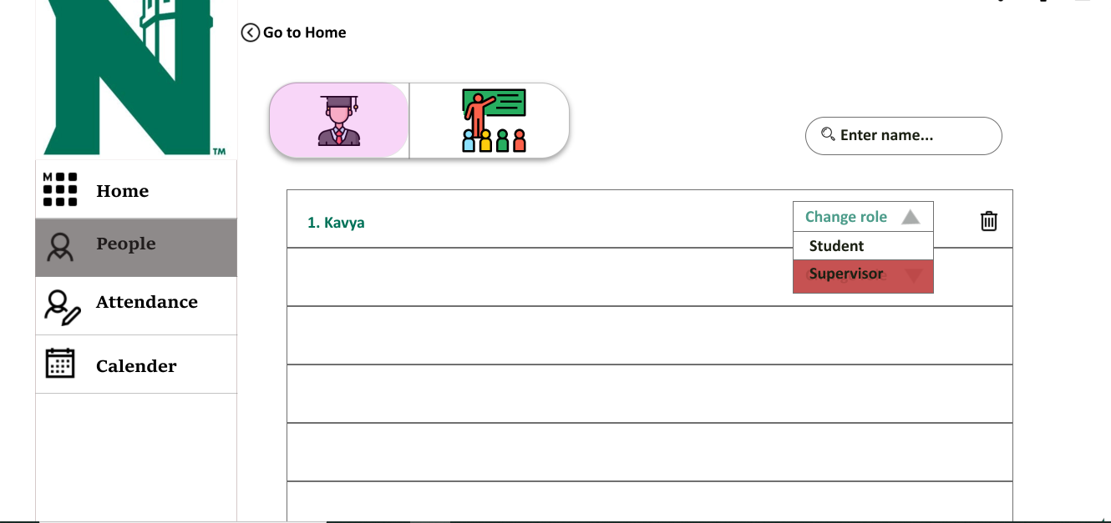

* 1. **STUDENT VIEW**

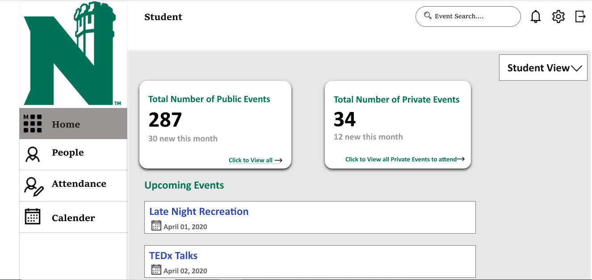

* + 1. View Upcoming Events

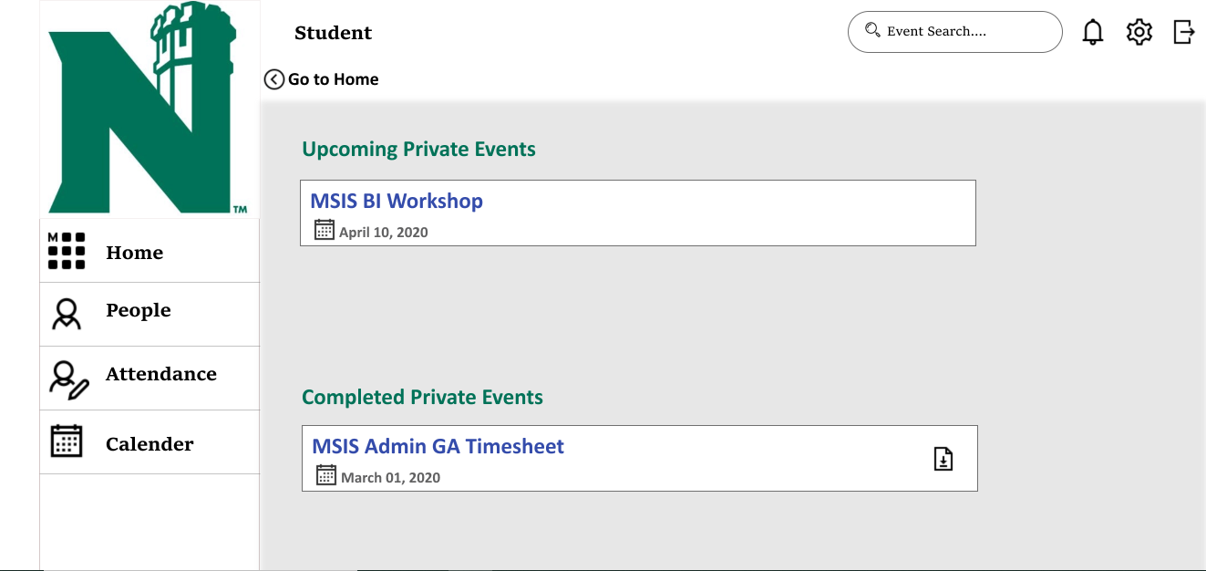

* 1. **Calendar**

<https://xd.adobe.com/view/8cb1775e-73c1-4447-563f-299e8175bcc5-fa80/screen/88928a3a-9626-4469-a588-ba257eb88f84/Login/>

1. **Summary**

Event tracking system helps the organizers to manage the event. It consists of three types of users which are Student, Admin and Supervisor. Event tracking system’s main objective is to develop an Event management system to help the event organizers to create, edit, delete and update the event as well as tracking and editing the participant attendance in the event. It allows the admin and supervisor to create both public and private events. Our main goal was to meet all the deliverables and milestones as planned.

In order to achieve our objective and goal, there are seven use cases which are as follows:

* Login to the Application
* Create an Event
* Update/Delete Events
* Edit/ Track Attendance
* Display Dashboard
* Update Holiday List
* Manage User Account

User Interface is the part of the system, which user interacts through. User Interface for the Event tracking system includes the screen displays that provide navigation to the users through the system, the displays allows the admin and supervisor to create private and public events and allows them to update and make changes on them. Admin is someone who have all the authorities, but the supervisors only have limited access as described in all the use cases. The interfaces in this project is designed to fulfill all the requirements mentioned for the project.

In order to make the admin and supervisor’s life easy this project helps to create a platform where all the actions are made easier. Creating and editing the events are easily done along with tracking their attendance.